**Appendix:**

**Tables:**

|  |  |  |  |
| --- | --- | --- | --- |
| **Requirement ID** | **Requirement Statement** | **Must/Want** | **Comments** |
| FR101 | Users shall be able to download the mobile app through an application store. The application shall be free to download. | Must |  |
| FR102 | The app shall notify users about new releases. Users shall download updates in the same way as they download the mobile application. | Must |  |
| FR103 | First-time user of the mobile application shall see the log-in page when he/she opens the application. | Must |  |
| FR104 | To be logged in the user shall provide username, password and click login. | Must | Database storing all accounts registered. |
| FR105 | The app shall send a request to the GeoFood webservice and authenticate users. | Must | Webservice communicates with our database and sends a response. |
| FR106 | The app shall display a response from the webservice with authentication status. | Must | Simple “success” or “wrong username/password” animation. |
| FR107 | The app shall store the log-in information on the phone and in the future the user should be logged in automatically. | Must |  |
| FR108 | The app shall let the user logout of their account. | Must |  |
| FR109 | The app shall display a menu with possible actions. | Must | “List of products”, “Add new product”, “Scan a QR Code”, “About us”, “Logout” |
| FR110 | Users shall be able to click buttons from the menu. | Must |  |
| FR111 | The app shall display detailed product descriptions consisting of name and location history. | Must |  |
| FR112 | The app shall organise the list of products by product name or ID. | Want |  |
| FR113 | The app shall have a functionality to delete products from the list. | Must |  |
| FR114 | The user shall be able to add new products and provide more information about them. | Must | Location, timestamp, device ID |
| FR115 | The app shall allow users to generate new QR Codes based on the given information. | Must |  |
| FR116 | The app shall allow the items in the catalogue to be searched. | Must |  |
| FR117 | The app shall allow users to scan QR codes on products. | Must |  |
| FR118 | The app shall allow users to update information about products. | Must |  |
| FR119 | Users shall be able to save QR Codes as a “png” or “pdf” file. | Must |  |

*Table 1: Functional Requirements for GeoFood Non-Consumer Mobile App.*

|  |  |  |  |
| --- | --- | --- | --- |
| **Requirement ID** | **Requirement Statement** | **Must/Want** | **Comments** |
| FR001 | The app shall have a login screen where the users can login or register an account. | Must | Database storing all accounts registered. |
| FR002 | The app shall have a ‘skip’ option to carry on as a guest if they rather not register/login. | Must |  |
| FR003 | The app shall allow users to scan QR codes on products. | Must | Database storing all QR codes with information. |
| FR004 | After scanning a product, the app shall display information about the item. | Must | Database storing all information to do with a certain QR code. |
| FR005 | The app shall have a history tab for users that have logged in to view their previous scans. | Want | Database storing history of scans. |
| FR006 | The app shall let the user logout of their account. | Must |  |
| FR007 | The app shall allow the user to search for a product’s information. | Want | The user will search a catalogue or our database. |
| FR008 | The app shall have an ‘about us’ section telling the users about our app. | Must |  |
| FR009 | The app shall display a map when the user asks for transport information. | Must | The transport history will be stored in databases by the farmer/drivers. |
| FR010 | The app shall display a history tab where the user can see all their recent scans. | Want |  |
| FR011 | The app shall allow any logged in users to favourite an item. | Want |  |
| FR012 | The app shall display all the users’ favourites when requested. | Want |  |

*Table 2: Functional Requirements for Geofood Consumer Mobile App.*

|  |  |  |  |
| --- | --- | --- | --- |
| **Requirement ID** | **Requirement Statement** | **Must/Want** | **Comments** |
| FR201 | The website shall have a home page that lists the purpose of the organisation. | Must | A clean, professional page to display most of the information. |
| FR202 | The homepage shall have link to the relevant app stores to download the app on the users preferred device. | Must | Google Play, Apple Store |
| FR203 | The homepage shall also have a section dedicated to product statistics. | Want | Top scanned products, best rating, hype, feedback and so on. |
| FR204 | The website shall have a search function. | Want | Search for a specific product. |
| FR205 | The website shall have a Contact/Helpdesk page. | Must | Email, Phone, Live chat - Businesses will be able to enquire about signing up. Also help or support with the app or any inquiries about the products. |
| FR206(a) | The website will have a Login page for businesses. | Must | Businesses will be able to login and manage their profile and catalogue. |
| FR206(b) | The website will have a Login page for admins. | Must | Administrators will be able to create/delete and view every catalogue and to edit/add/delete and view the products history. |
| FR207 | The website shall have a Logout page. | Must | Users will be able to Logout of their accounts. |
| FR208 | The website shall be linked to a database. | Must | All catalogues, products, accounts and statistics will be pulled from said database. |
| FR209 | The website shall have an algorithm that will calculate how “good” a product is. | Want | It will take all the products’ attributes, travelled distance, pollution and so on that were inputted by the user and give it a rating out of 100%. |

*Table 3: Functional Requirements for Geofood Website.*

**Figures:**

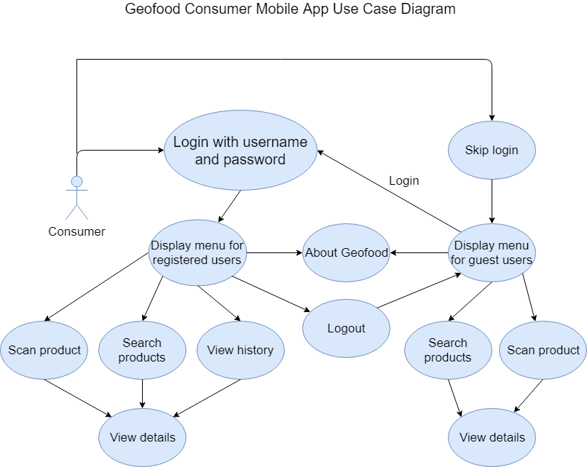

*Figure 1: Geofood Consumer Mobile App Use Case Diagram.*

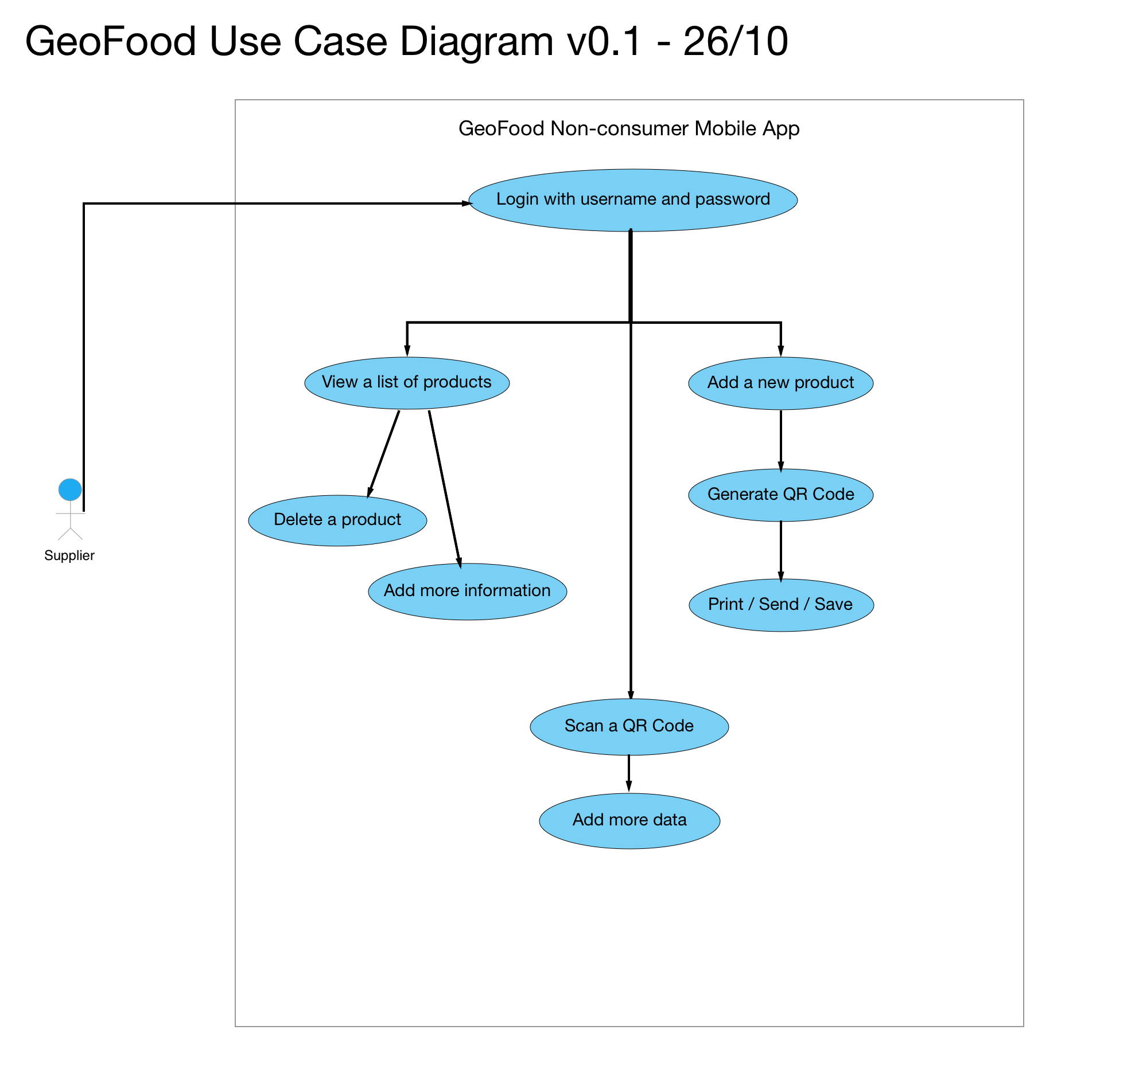

*Figure 2: Geofood Non-Consumer Mobile App Use Case Diagram.*

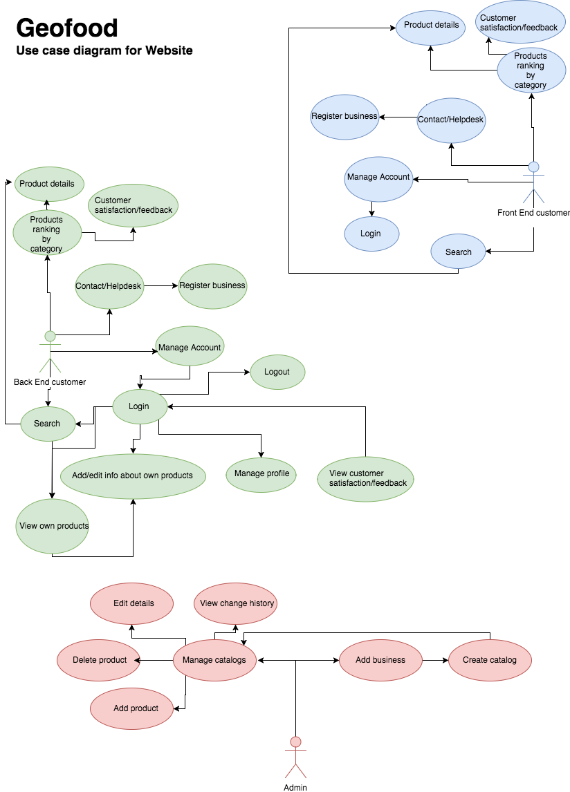

*Figure 3: Geofood Website Use Case Diagram.*

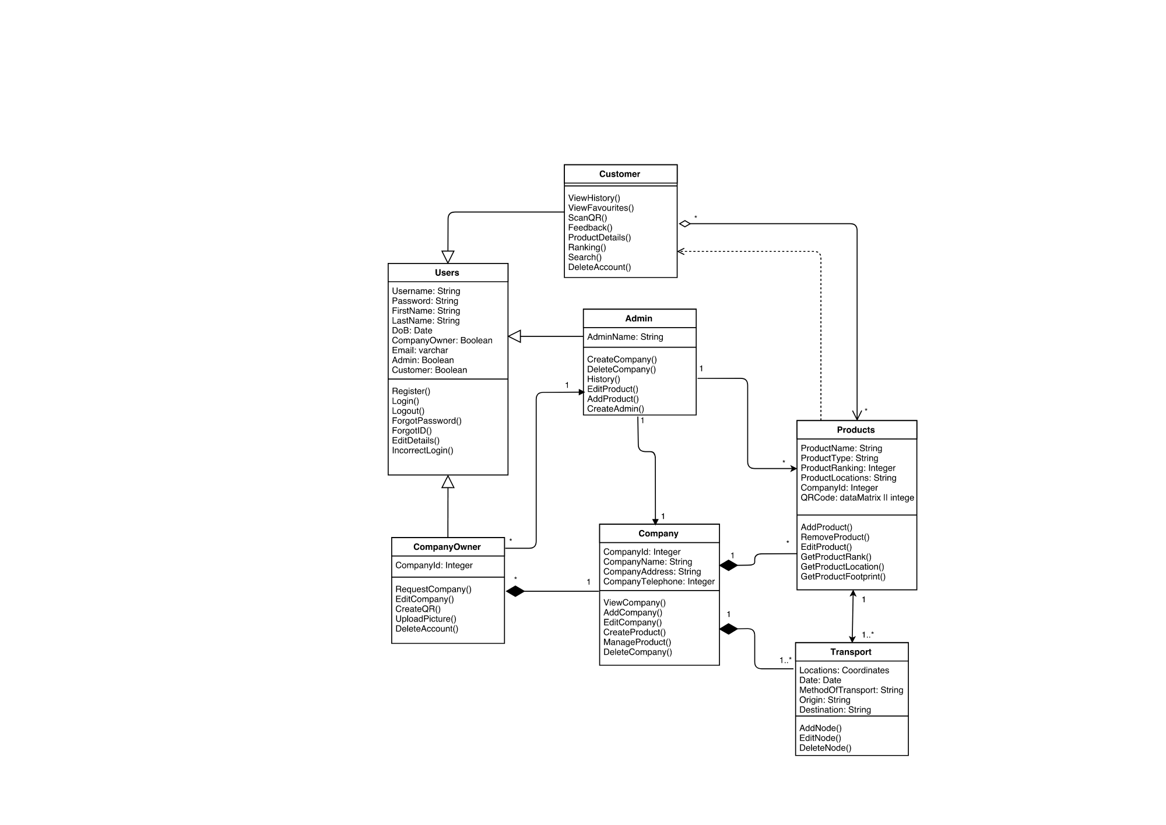

*Figure 4: Full Class Diagram.*

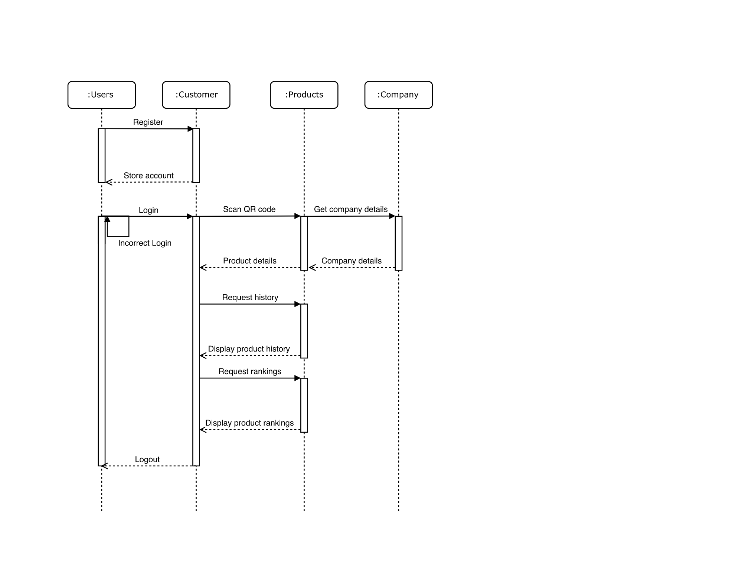

*Figure 5: Sequence Diagram for Customers*

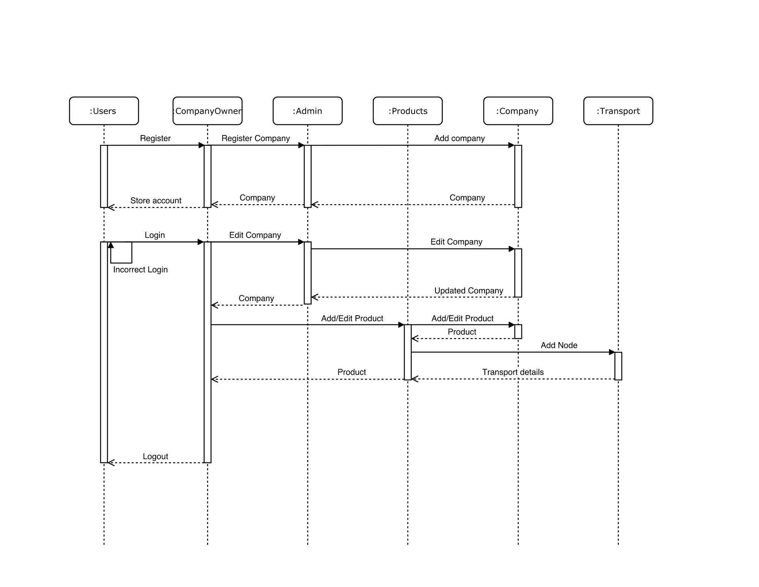

*Figure 6: Sequence Diagram for Company Owners.*

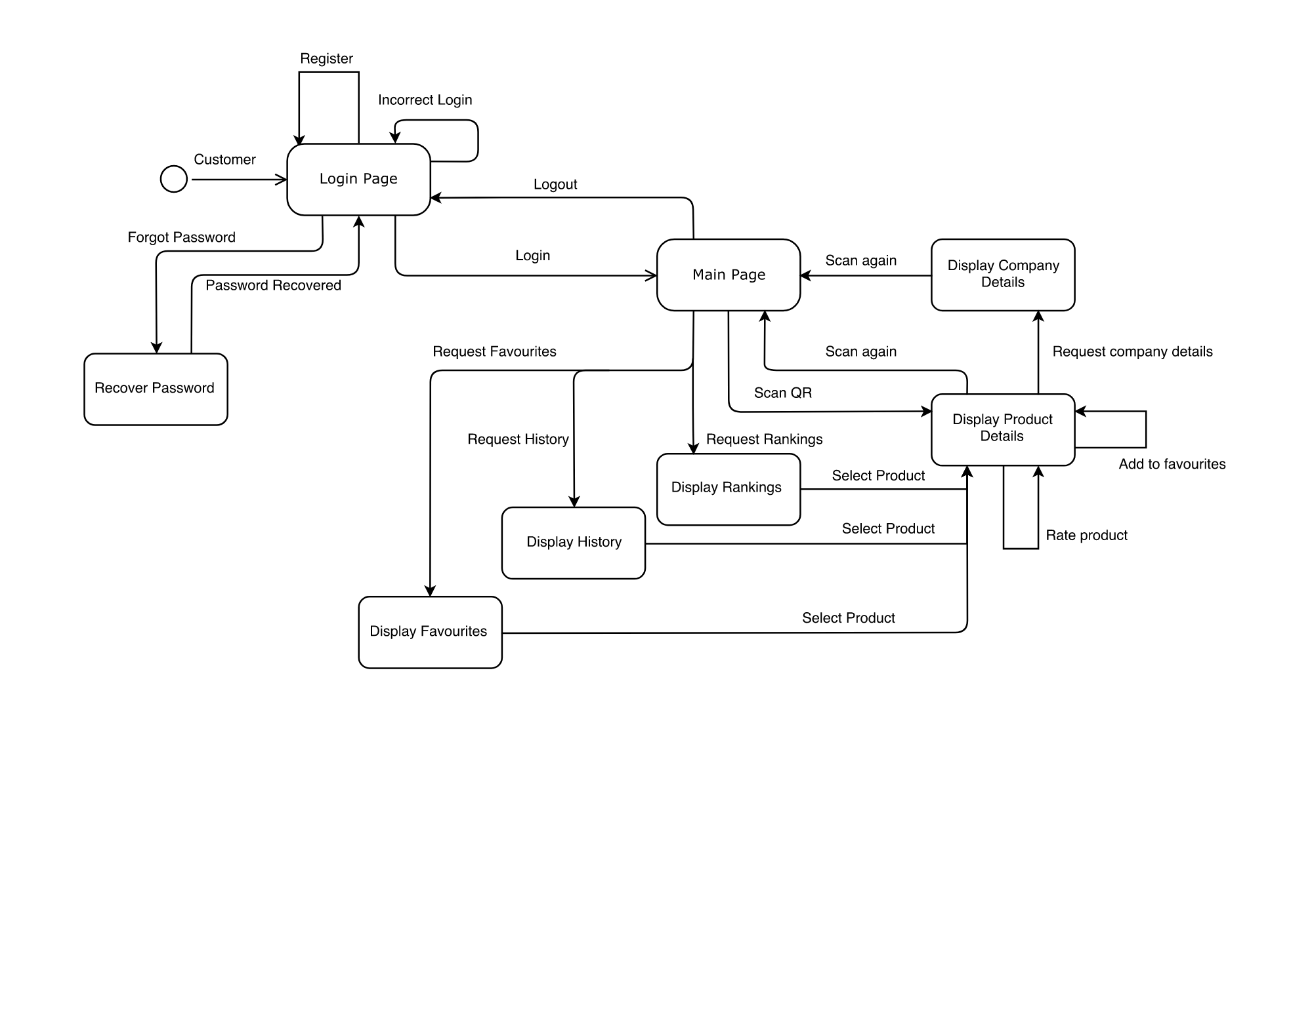

*Figure 7: State Diagram for Customers.*

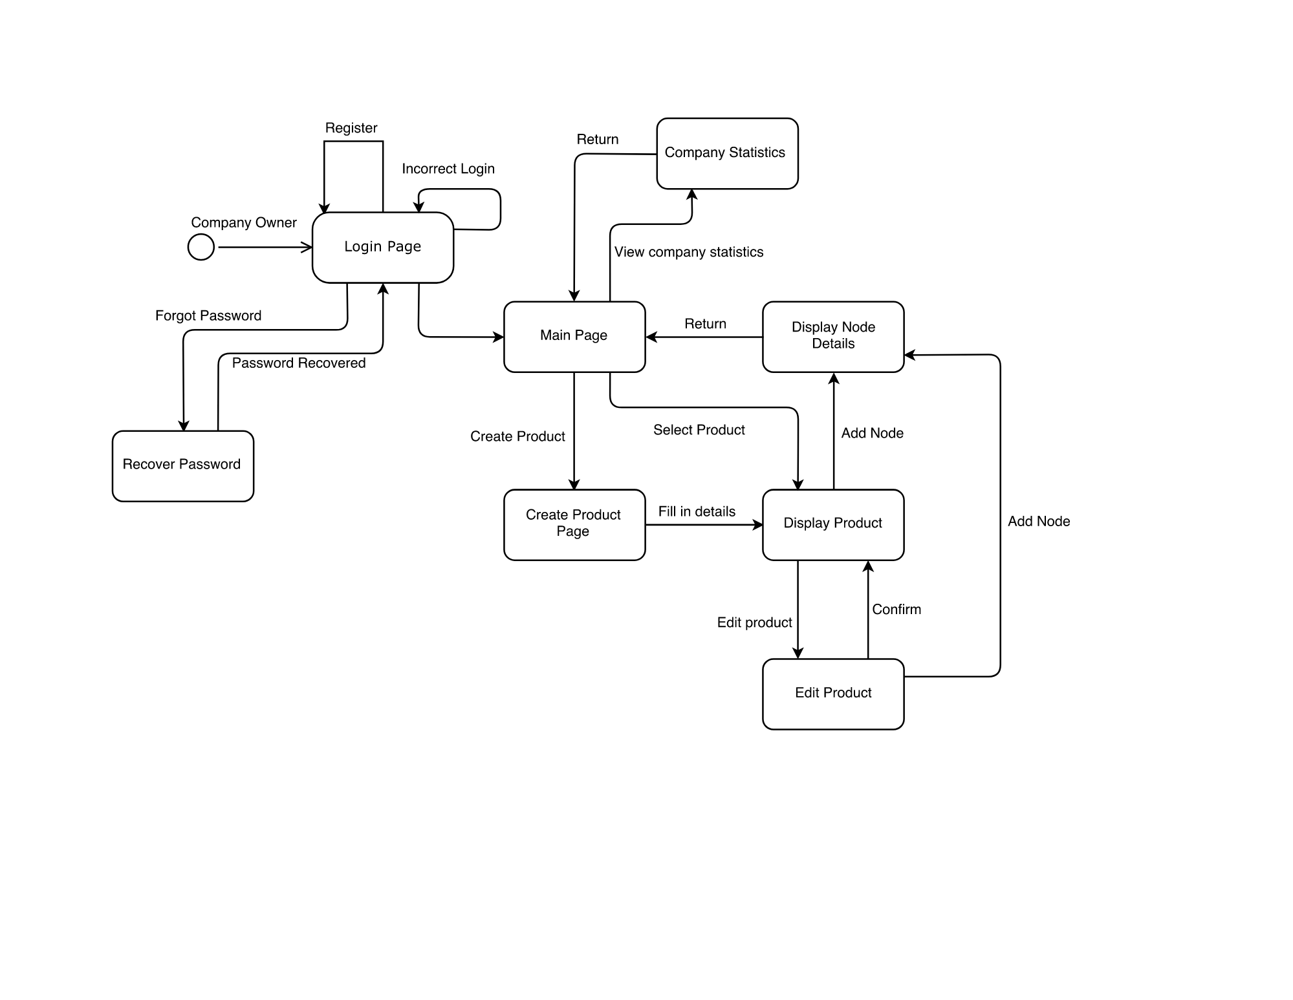

*Figure 8: State Diagram for Company Owners.*

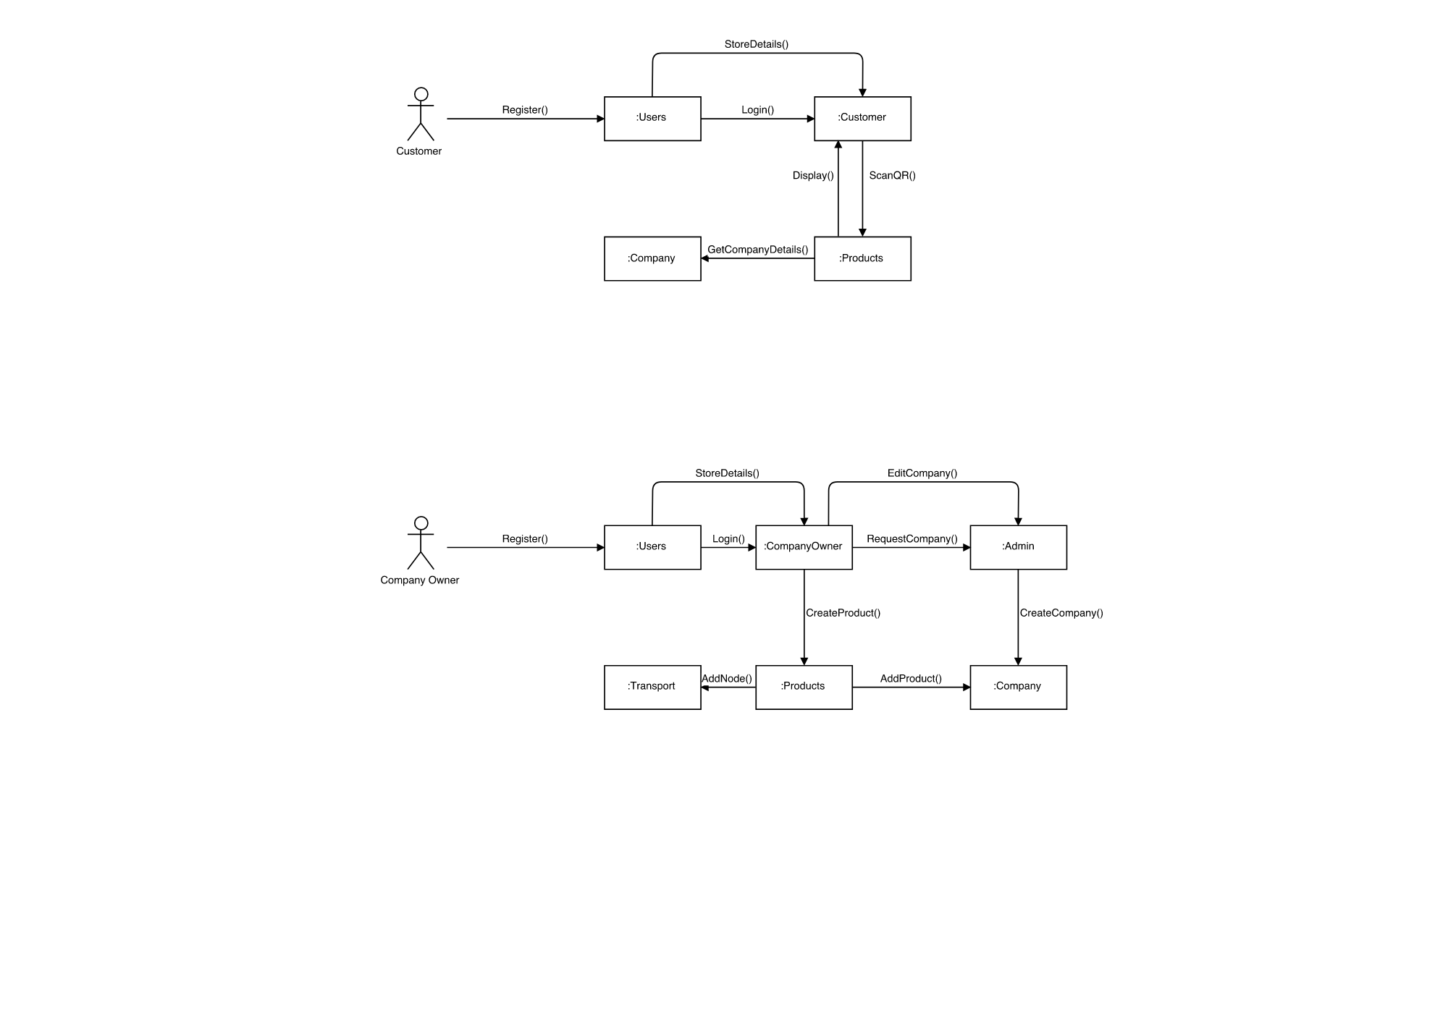

*Figure 9: Collaboration Diagram for Customers.*



*Figure 10: Collaboration Diagram for Company Owners.*

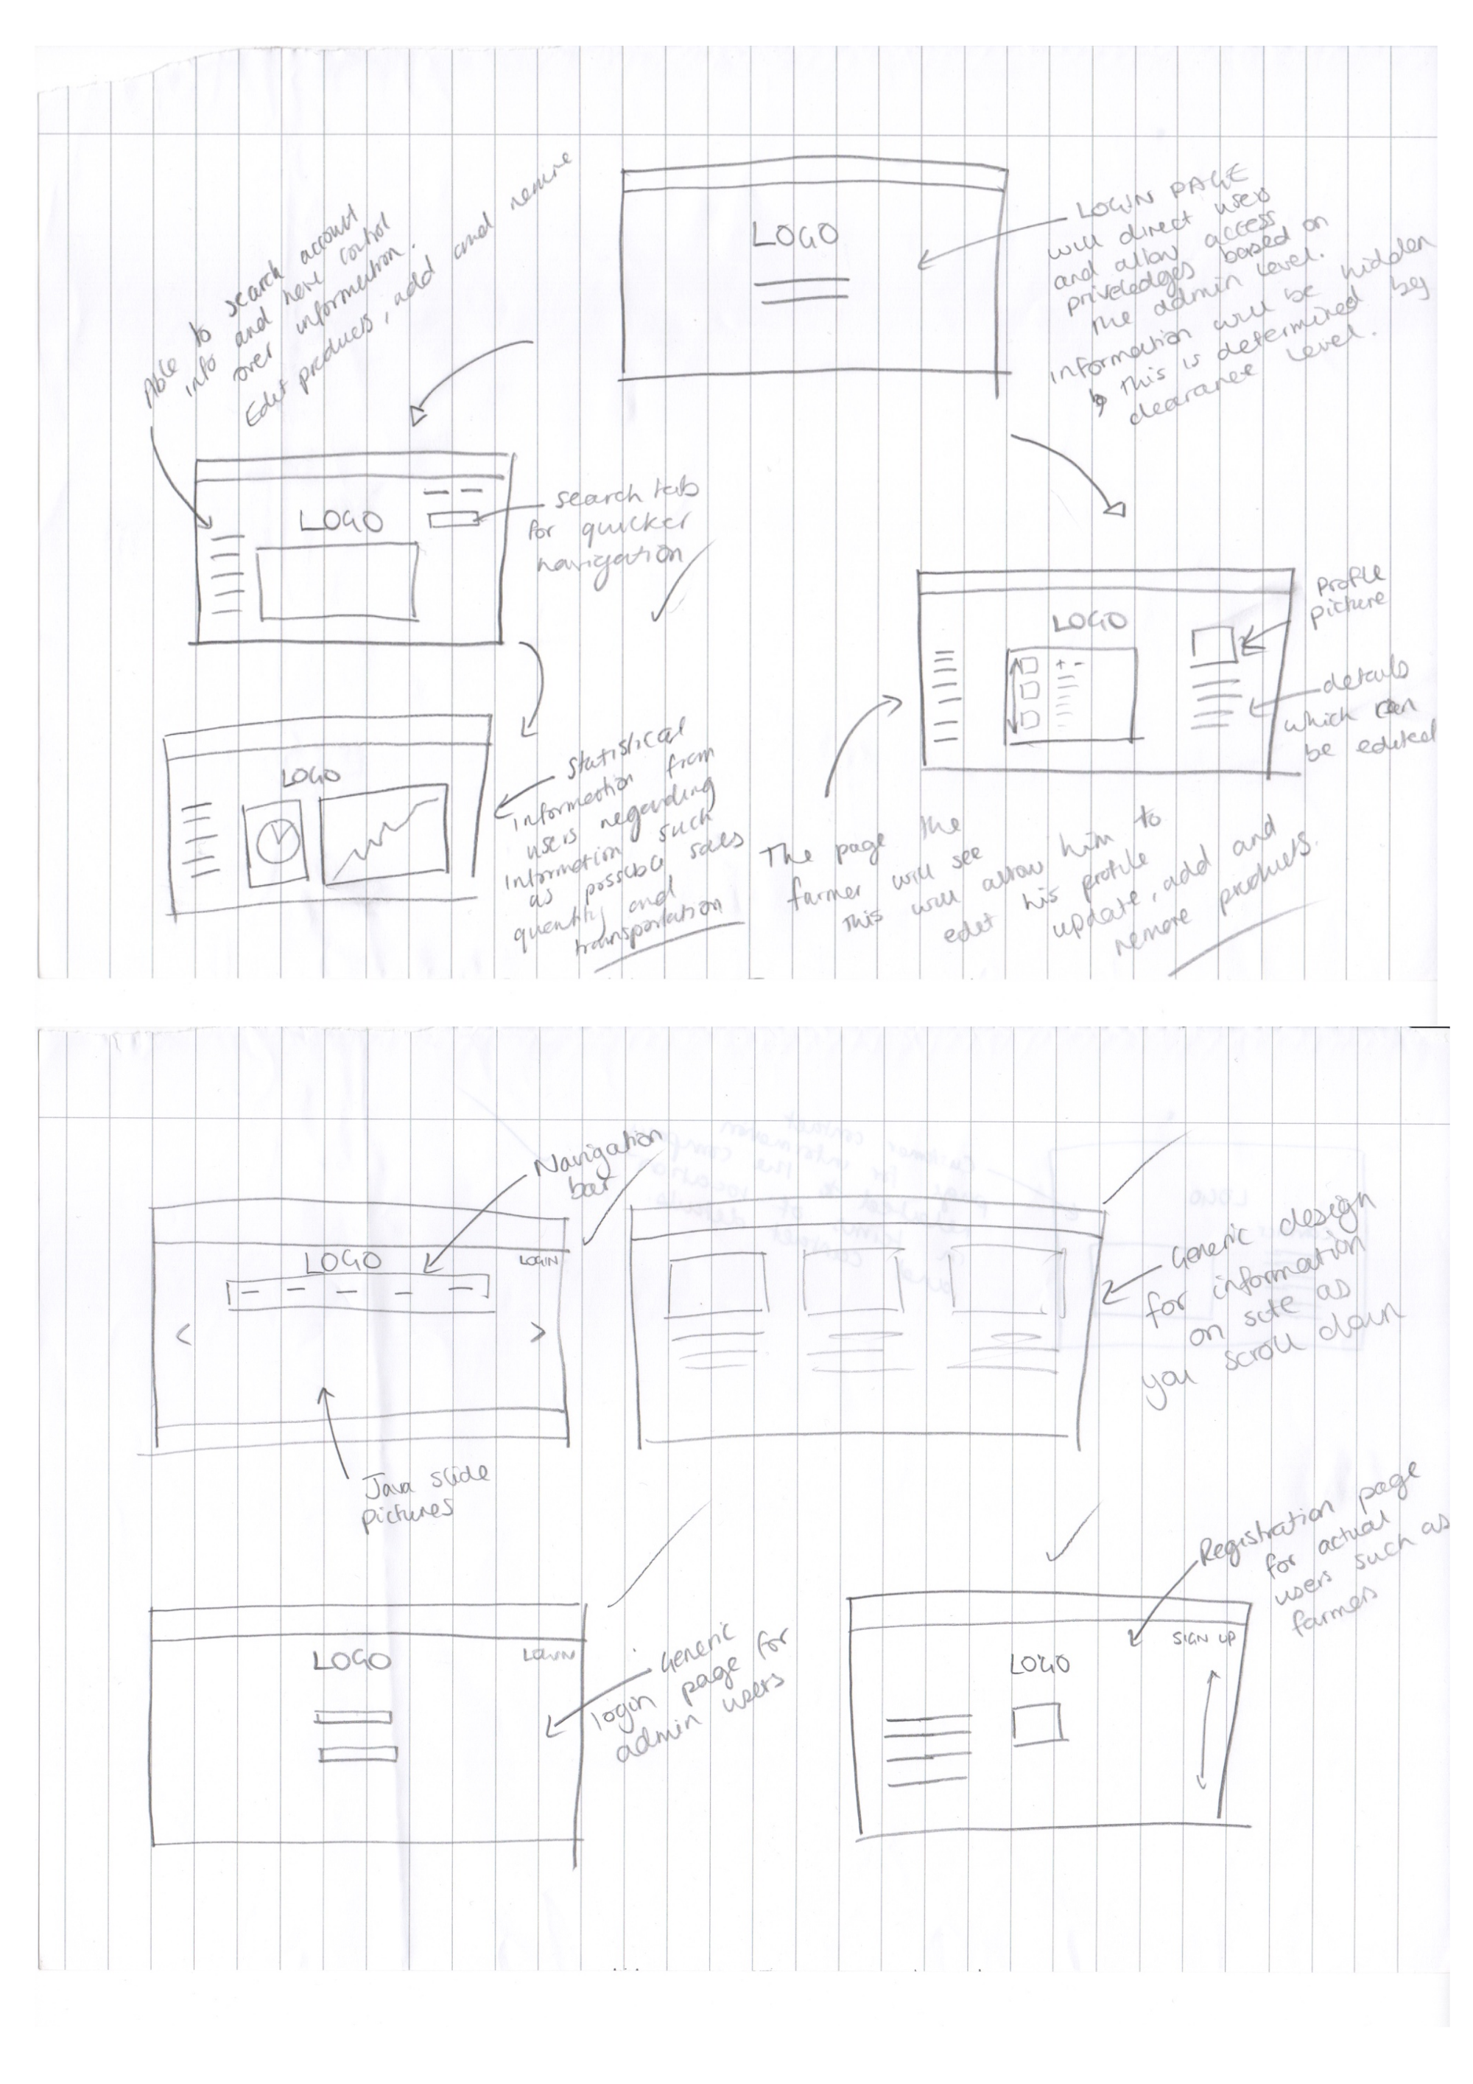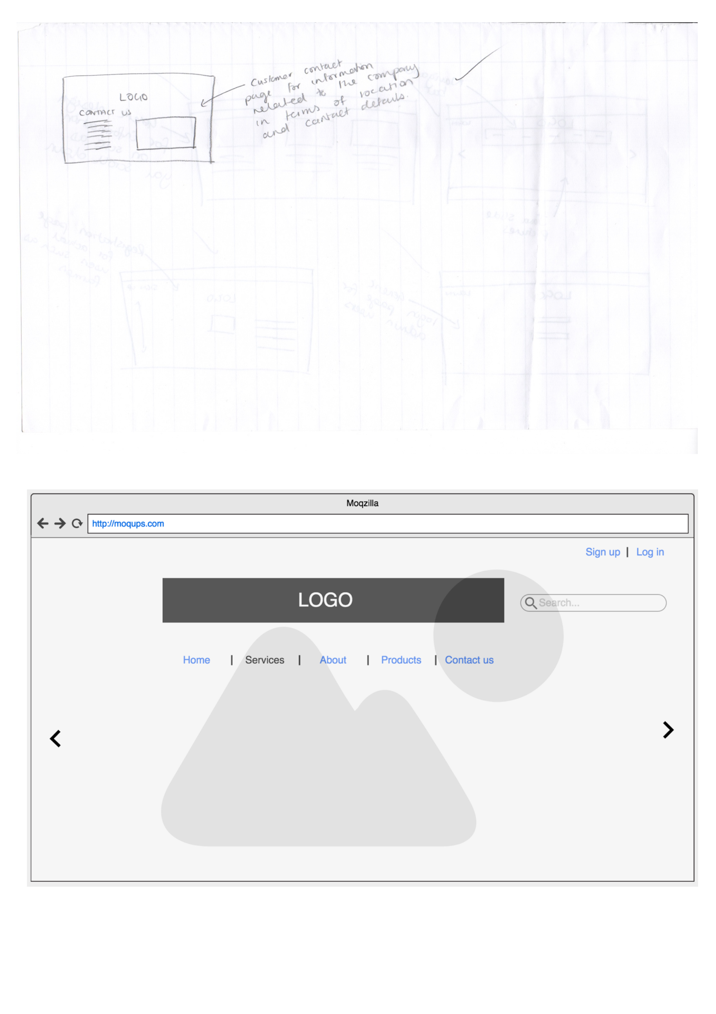

*Figure 11: Paper wireframes/prototypes of website.*



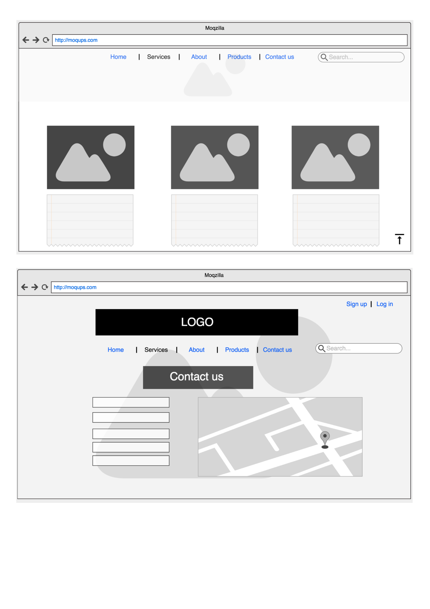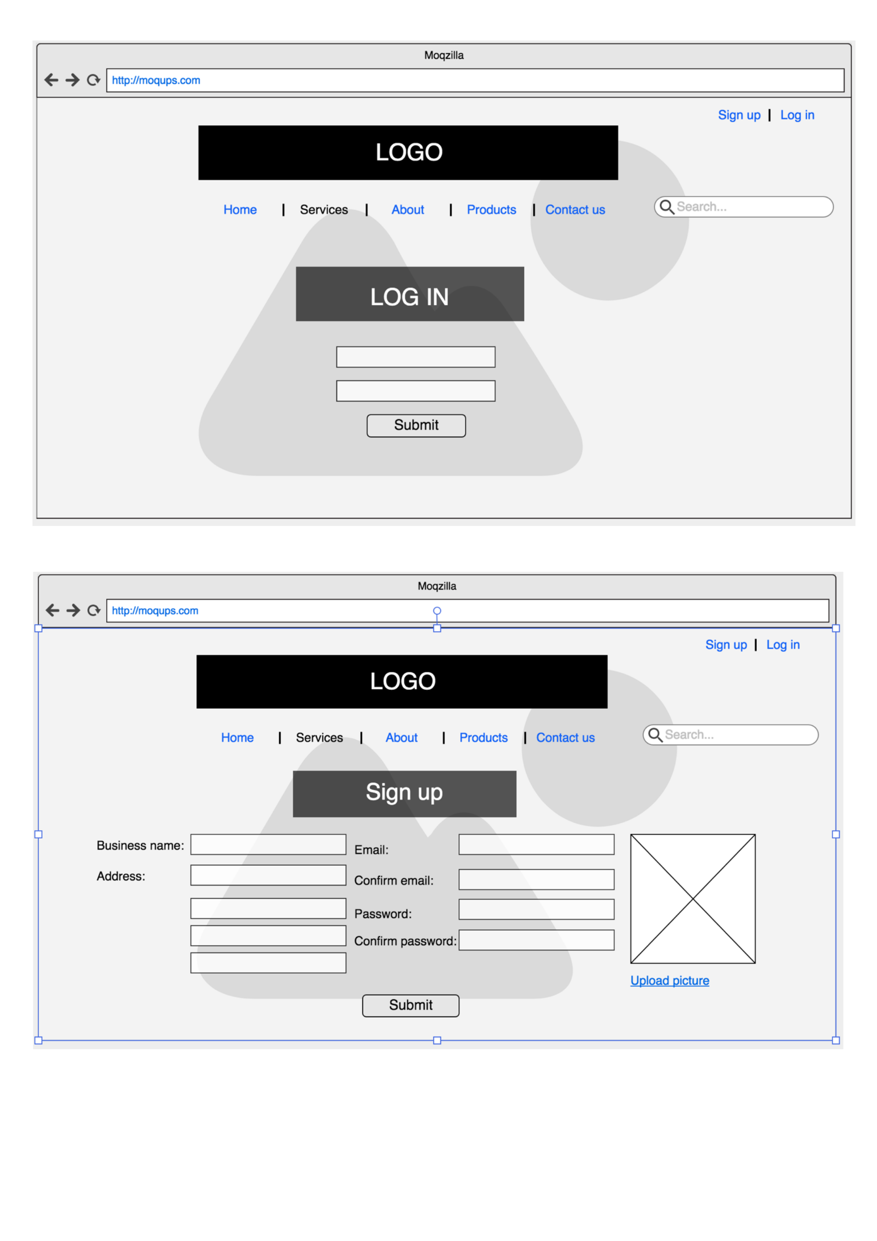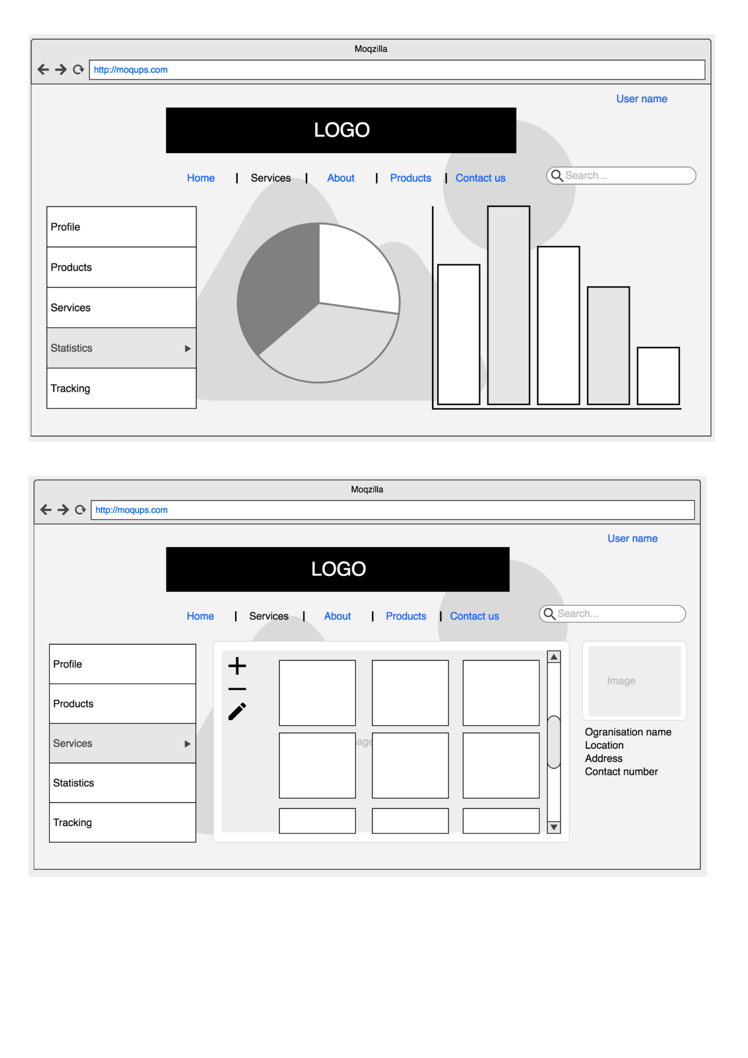

*Figure 12: Digital wireframes/prototypes.*

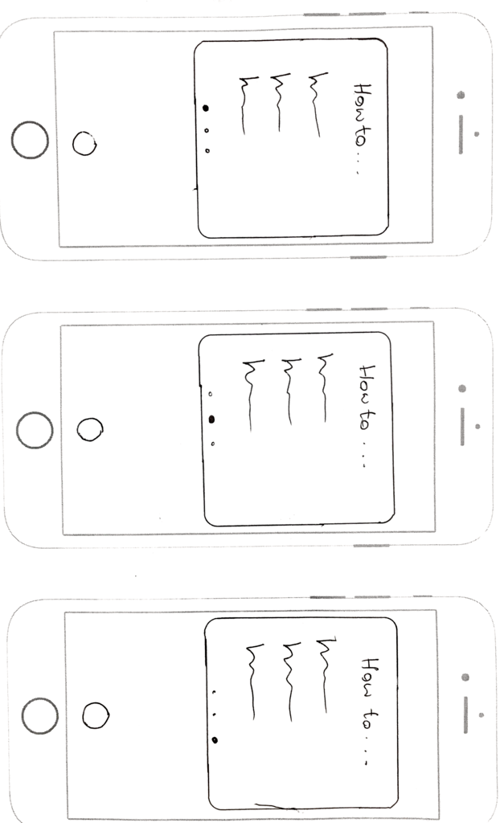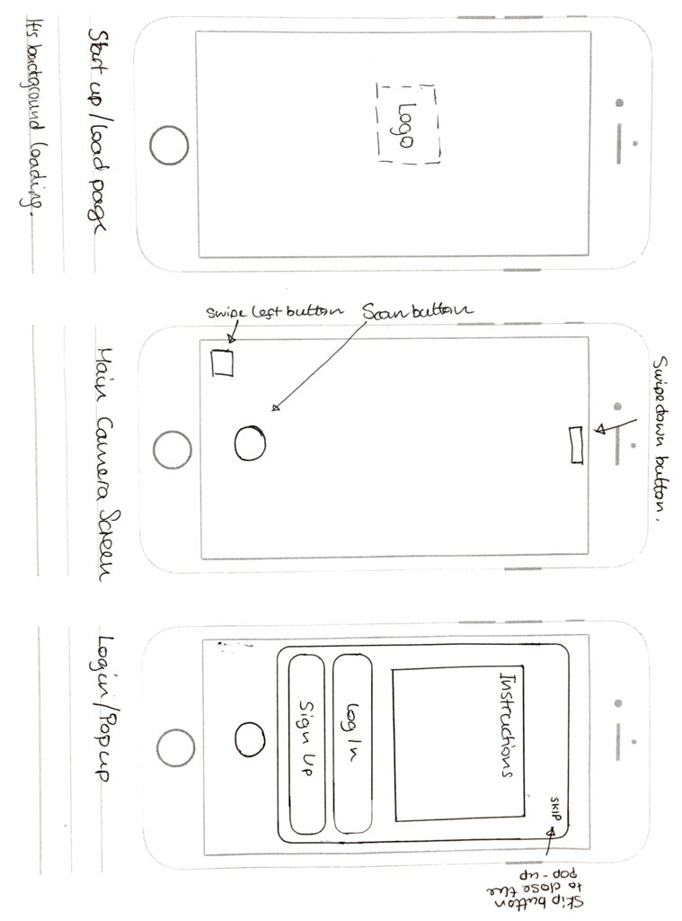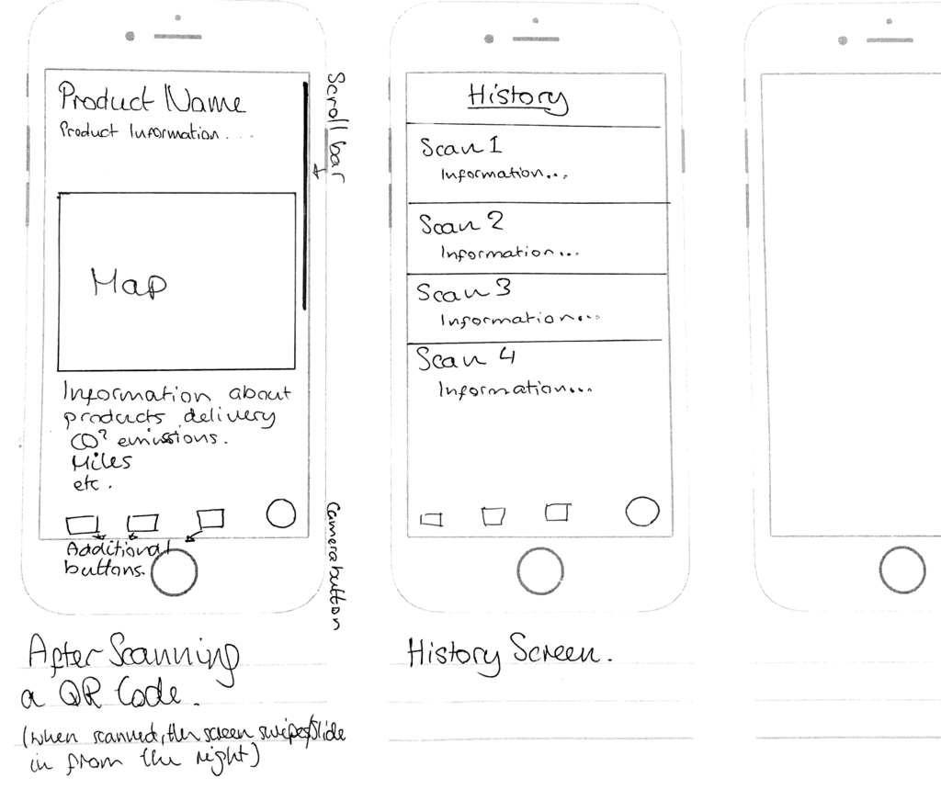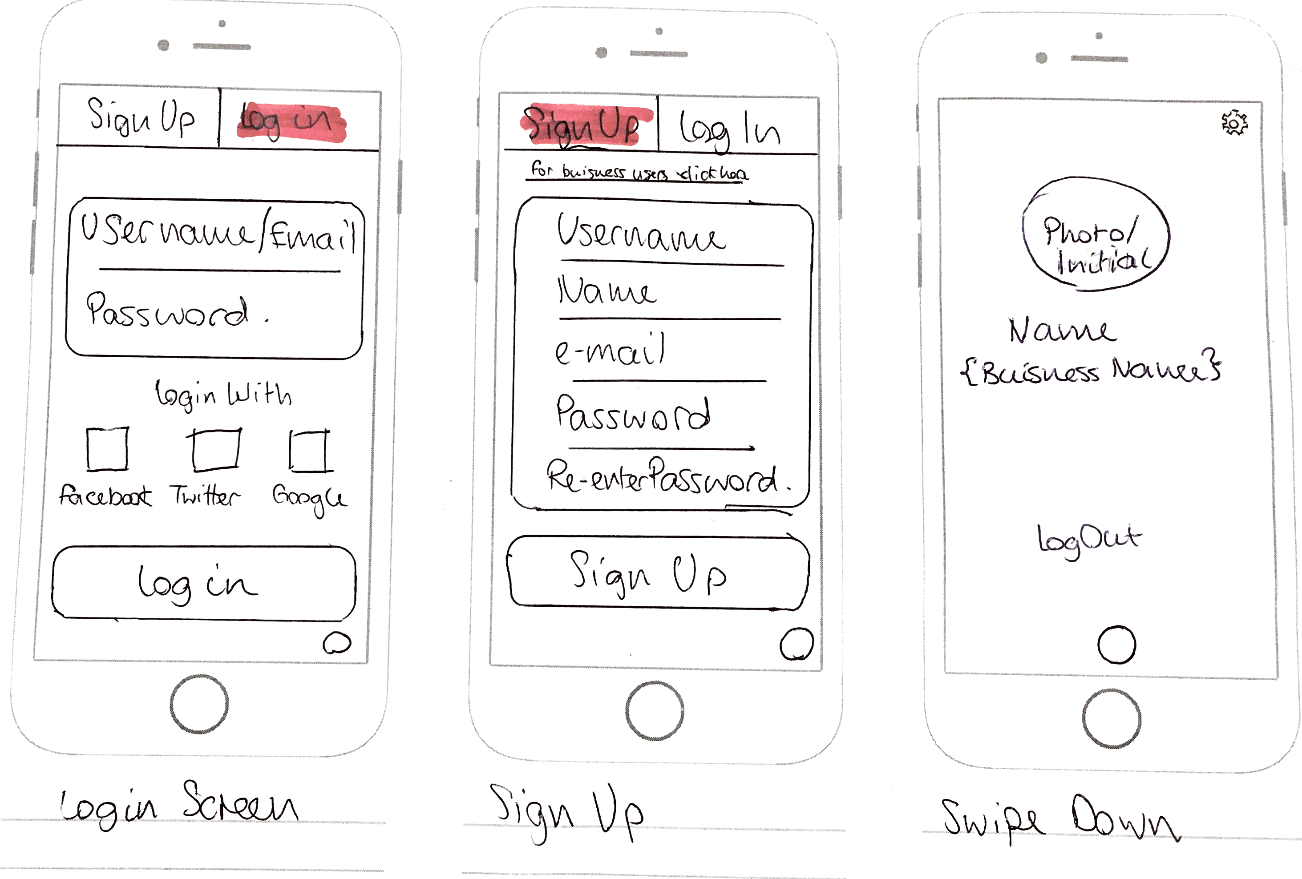

*Figure 13: Paper wireframes/prototypes for Mobile App.*

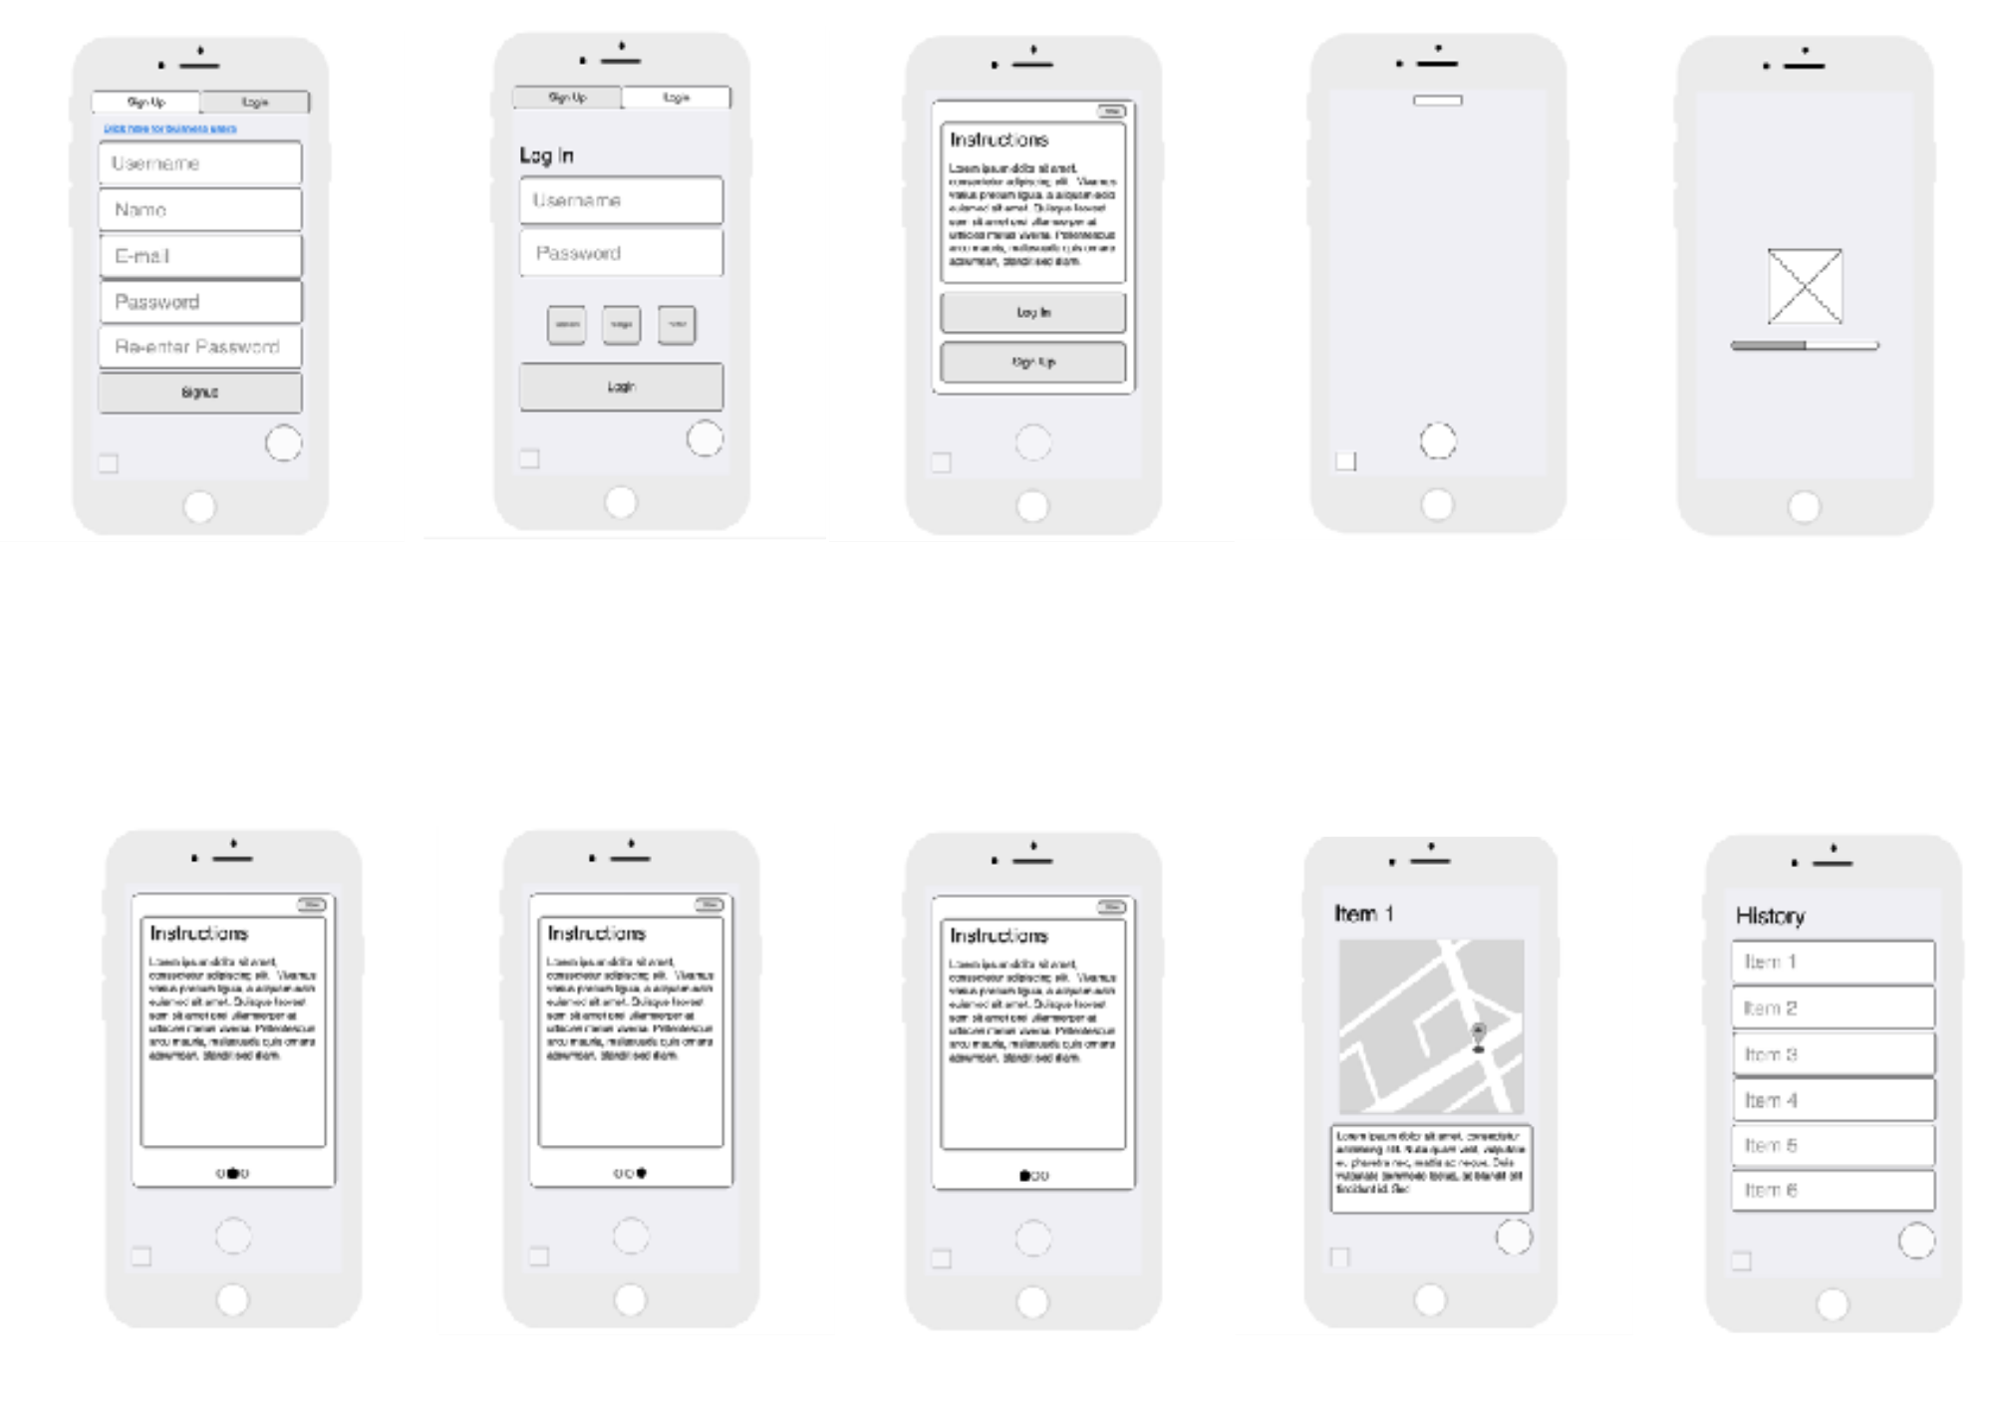

*Figure 14: Digital wireframes/prototypes for Mobile App.*

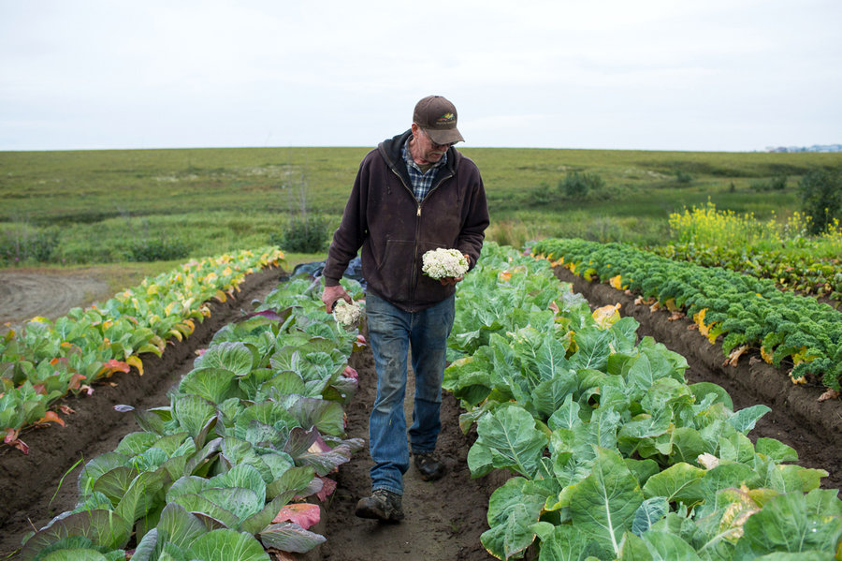

**Name:** Albert Jones

**Occupation:** Farmer

**Age:** 56

**Location:** Yorkshire

**Tier:** Master Farmer

*Introduction:*

Albert is a farmer that has been farming for his whole life and specialises in farming high quality grass fed cows. He is very dedicated to his farm where he also grows root vegetables and sells his products to the local grocery and butchers.

*Goals:*

Albert has a been breeding grass fed cows for a very long time and is trying to expand his business and customer base. He believes his cows are high in value due to the way he farms them. He has advertised his farm online but wants people to be more aware of what he does in his farm and the quality of his products.

*Targets and motivation:*

* Constantly increasing the quality of his products
* Make people aware of the quality of his products
* Be more technologically active
* To get payed the proper value for his products and possibly expand his business to have more customers

*Dislikes:*

* Albert dislikes the direction farming is going such as mass farming and believe its damaging the essence of farming and quality of food being sold to the public.
* He also dislikes companies trying to rip farmers off.

[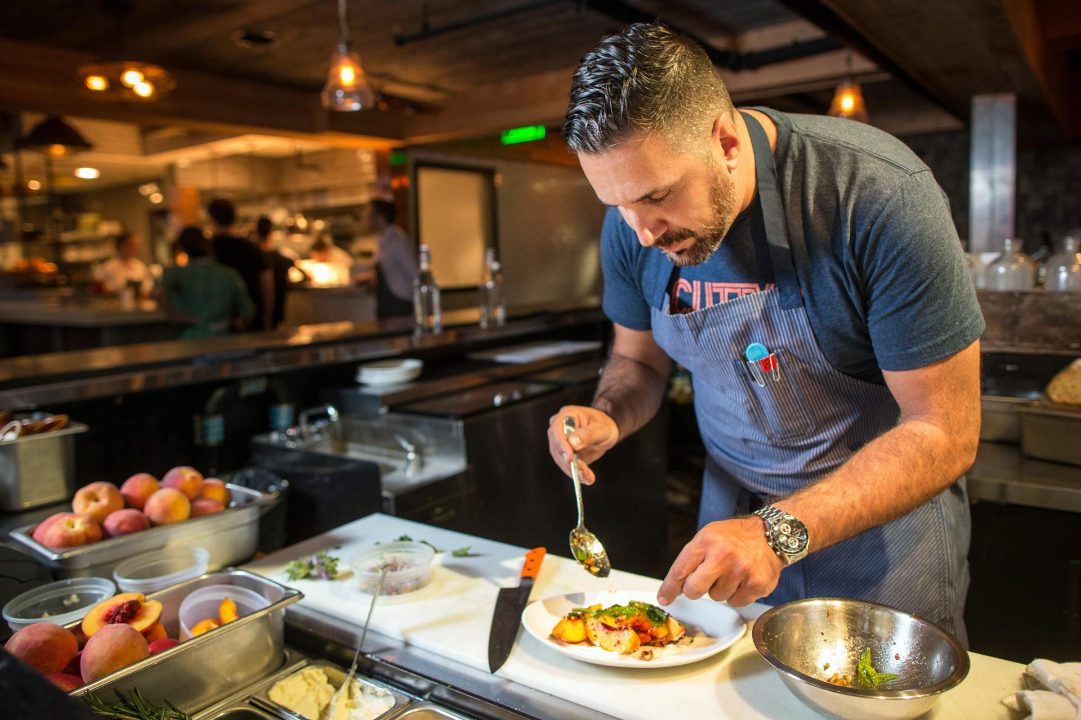](https://camo.githubusercontent.com/e7b809fc210edfdc4847ce6a9f19cf16ed17a9dc/68747470733a2f2f692e70696e696d672e636f6d2f6f726967696e616c732f38392f35642f61302f38393564613037633632323463643461646433383865636131386234326237362e6a7067)

**Name:** Wilson McKenzie

**Occupation:** Store/Café/Restaurant Owner

**Age:** 29

**Location:** London

**Tier**: Owner/Manager

*Introduction:*

Wilson is a young entrepreneur whose opened his own grocery store where he sells high quality organic grocery products sourced from local area and believes that local small businesses should help each other and offer better and healthier products to local communities.

*Goals:*

Wilsons goal is to make people more aware of the products that they buy as he states all possible information available about products he sells. He’s trying to implement a better technological interaction with his customers. *Targets and motivation:*

* Promote local businesses and organic products
* Make people aware of items that they buy
* Customers that support his vision of quality and community

*Dislikes:*

* Wilson is against selling products that are not of decent quality.
* He also dislikes businesses who do not care for their customers and use mass production.
* He also doesn’t like “fake” foods which are full of chemicals and bad for your health



**Name:** Elvis Green

**Occupation:** Liberal arts student

**Age:** 22

**Location:** London

**Tier:** Hipster

*Introduction:*

Elvis considers himself a hipster. He is an independent-thinker that values counter-culture, progressive politics and has an appreciation of art, creativity, intelligence and witty banter. He rejects the culturally-ignorant attitudes of mainstream consumers He follows the latest trends and fashion especially those regarded as being outside the cultural mainstream.

*Goals:*

Eat healthy. He would rather go to a small independent shop rather than a big supermarket to buy his groceries even though he knows it’s more expensive, so he can help the small businesses. Also, he promotes healthy eating in his friend circle and always suggests what to eat and where.

*Targets and motivation:*

* Healthy eating
* He likes the warmness and friendliness of a small shop rather than a big chain where he feels more valued
* Helps local businesses and promote organic food in his community

*Dislikes:*

* Big chains and superstores
* Pollution
* Food full of artificial ingredients
* Mainstream stuff
* Trump

[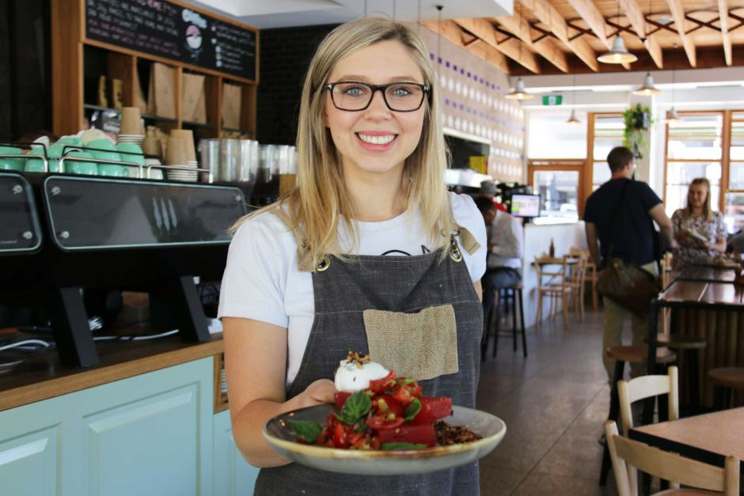](https://camo.githubusercontent.com/c9c08c1d599c78bccc355a46d670e37961cad82a/687474703a2f2f7777772e6162632e6e65742e61752f6e6577732f696d6167652f373032383034302d3378322d393430783632372e6a7067)

**Name:** Ellie Marsh

**Occupation:** Supervisor

**Age**: 27

**Location**: London

**Tier:** Hospitality worker

*Introduction:*

Ellie works in hospitality and her schedule can be busy or quiet depending on the hours she is doing every week. When she is busy she does not have time to cook so she would rather eat out or buy ready-made food. On her quiet days she’d rather go to the local grocery store and buy organic food, cook and eat at home.

*Goals:*

She would love to eat healthy but due to her schedule she does not have the time to do so. She is not really fussed about where the products are from and how are they made but whenever is in the situation to pick from 2 of the same products she always picks the organic one and the one that is fair trade. By doing this she does not feel as guilty.

*Targets and motivation:*

* Healthy eating
* She likes the friendliness of the local shops and cafes as she can chat with the owner about the products

*Dislikes:*

* “fake food”
* pork because she thinks pigs are cute
* complicated tasks, she would like to have everything at a click of a button
* lack of information

*Figure 15: Example of personas (mentioned in data gathering).*